

Semester One Examination, 2019

Question/Answer booklet

MATHEMATICS METHODS
UNIT 3

Section Two:

Calculator-assumed

Your Name:
Your Teacher’s Name:

Time allowed for this section
Reading time before commencing work: ten minutes
Working time: one hundred minutes

Materials required/recommended for this section
To be provided by the supervisor
This Question/Answer booklet
Formula sheet (retained from Section One)

To be provided by the candidate
Standard items: pens (blue/black preferred), pencils (including coloured), sharpener, correction fluid/tape, eraser, ruler, highlighters

Special items: drawing instruments, templates, notes on two unfolded sheets of A4 paper, and up to three calculators approved for use in this examination

Important note to candidates
No other items may be taken into the examination room. It is your responsibility to ensure that you do not have any unauthorised material. If you have any unauthorised material with you, hand it to the supervisor before reading any further.

Question | Marks | Max | Question | Mark | Max
8 |  | 6 | 15 |  | 8
9 |  | 8 | 16 |  | 8
10 |  | 6 | 17 |  | 10
11 |  | 4 | 18 |  | 8
12 |  | 10 | 19 |  | 8
13 |  | 9 | 20 |  | 8
14 |  | 8

Structure of this paper

Section | Number of questions available | Number of questions to be answered | Working time (minutes) | Marks available | Percentage of examination
Section One:  Calculator-free | 7 | 7 | 50 | 52 | 34
Section Two:  Calculator-assumed | 13 | 13 | 100 | 103 | 66
 |  |  |  | Total | 100

Instructions to candidates

- The rules for the conduct of the Western Australian Certificate of Education ATAR course examinations are detailed in the Year 12 Information Handbook 2019. Sitting this examination implies that you agree to abide by these rules.

- Write your answers in this Question/Answer booklet.

- You must be careful to confine your answers to the specific questions asked and to follow any instructions that are specific to a particular question.

- Additional pages for the use of planning your answer to a question or continuing your answer to a question have been provided at the end of this Question/Answer booklet. If you use the space to continue an answer, indicate in the original answer space where the answer is continued, i.e. give the page number.

- Show all your working clearly. Your working should be in sufficient detail to allow your answers to be checked readily and for marks to be awarded for reasoning. Incorrect answers given without supporting reasoning cannot be allocated any marks. For any question or part question worth more than two marks, valid working or justification is required to receive full marks. If you repeat any question, ensure that you cancel the answer you do not wish to have marked.

- It is recommended that you do not use pencil, except in diagrams.

- The Formula sheet is not to be handed in with your Question/Answer booklet.

Section One: Calculator-assumed (103 Marks)

This section has thirteen questions. Answer all questions. Write your answers in the spaces provided.

Spare pages are included at the end of this booklet. They can be used for planning your responses and/or as additional space if required to continue an answer.
● Planning: If you use the spare pages for planning, indicate this clearly at the top of the page.
● Continuing an answer: If you need to use the space to continue an answer, indicate in the original answer space where the answer is continued, i.e. give the page number. Fill in the number of the question that you are continuing to answer at the top of the page.

Working time: 100 minutes.

Question 8 (6 marks)

Consider the following table with

$x$ | 1 | 2 | 3 | 4 | 5
$P\left(X≤x\right)$ | 0.1 | 0.4 | 0.7 | 0.9

- Complete the probabilities in the table below (2 marks)

Solution
$x$ | 1 | 2 | 3 | 4 | 5
$P\left(X=x\right)$ | 0.1 | 0.3 | 0.3 | 0.2 | 0.1

Specific behaviours
✓ determines probs for x= 2 & 3
✓ determines probs for all x values

- Find $P(x≥4)$ (1 mark)

Solution
Specific behaviours
✓ determines prob by adding for x=4 & 5

- Find $P(x>2|x<4)$(simplify) (3 marks)

Solution
Specific behaviours
✓ uses conditional prob formula
✓determines correct quotient of probs
✓expresses as simple fraction of integers

Question 9 (8 marks)

A liquid is spilled onto a floor forming a circle of radius $r$ metres. The surface area, $A$, square metres, of the spilt liquid is given by $A=\int_{0}^{r}{}15e^{\frac{x^{3}}{20}}dx$.

- Determine $\frac{dA}{dr}$ when $r=5$ metres. (2 marks)

Solution

Approx. 7770.2
Specific behaviours
✓ uses fundamental theorem
✓ states an approx value for rate

- What is the meaning of your answer in (a) above? (2 marks)

Solution
rate of change of area with respect to radius.

Specific behaviours
✓ states a rate
✓ with respect to radius

The radius, $r$, varies with time, $t$ seconds, by the model $r={\left(5t^{2}+1\right)}^{4}$.

- Determine $\frac{dA}{dt}$ when $t=1$ second as an exact value. (4 marks)

Solution
Specific behaviours
✓ states derivative of radius wrt time and radius at t=1
✓ uses chain rule with
✓ uses fundamental theorem
✓ gives an exact expression(no need to simplify)

Question 10 (6 marks)

Two power poles need to be joined using a wire that is also connected to the ground, as shown below. The two poles are 10 and 20 metres high, and are separated by 30 metres.

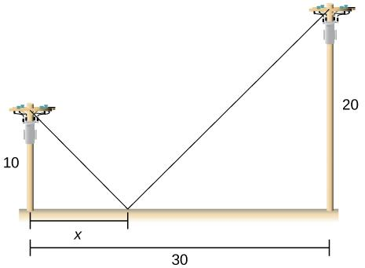

- Determine an expression for the length of wire needed in terms of $x$ metres. (2 marks)

Solution
Specific behaviours
✓ uses Pythagoras with x
✓ states total length in terms of x

- Using calculus, show how to determine the value of $x$ to minimize the length of wire required. Determine this length to the nearest centimetre.
(Use of a classpad is required) (4 marks)

Solution
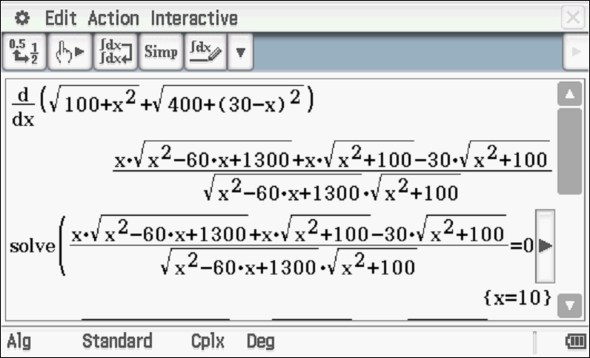
Second derivative at x=10 is positive as shown below:
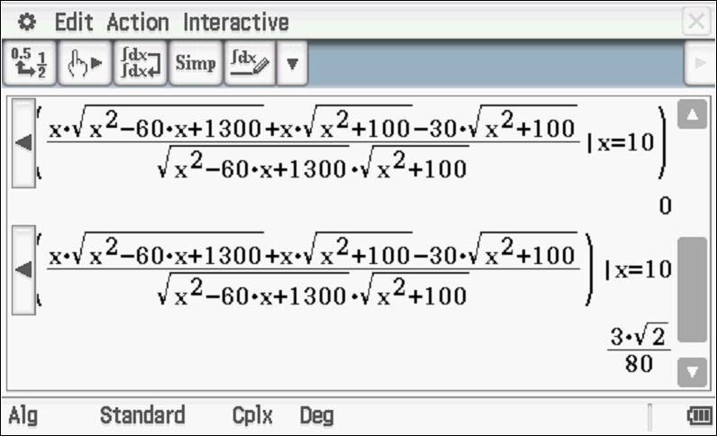
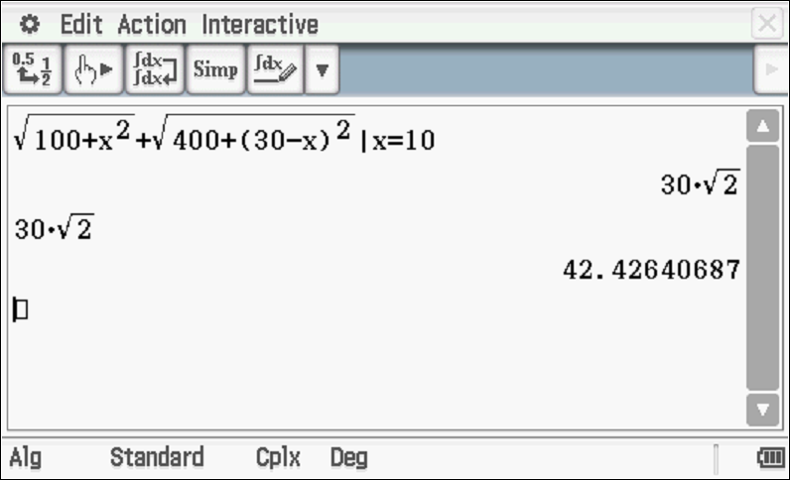
Length = 42.43 metres(4243cm)
Specific behaviours
✓ states derivative of length in terms of x
✓ equates derivative to zero and solves for x
✓ states total length of wire to nearest cm
✓ uses second derivative sign test or first derivative to show a minimum

Question 11 (4 marks)

Part of the graph of $y=f(x)$ is shown below. The areas of regions A and B, bounded by the curve and the $x$-axis, are 16 and 2 square units respectively.

Evaluate:

- $\int_{2}^{3}{}f(x) dx$ (1 mark)

Solution
-2

Specific behaviours
✓ states integral value

- $\int_{0}^{3}{}f(x) dx$ (1 mark)

Solution
16-2=14

Specific behaviours
✓ states total value

- $\int_{0}^{2}{}f(x)-3 dx$ (2 marks)

Solution
Specific behaviours
✓ uses linearity and breaks into two integrals
✓ states value

Question 12 (10 marks)

A train on a monorail moves with velocity, $v$ metres per second, at time $t$ seconds, in a straight line, with acceleration, $a$ metres per second squared, given by:

$a=5sinsin \left(3t+\frac{π}{2}\right)$

The train begins at the origin and at rest.

Determine:

- The greatest speed of the train. (2 marks)

Solution
Specific behaviours
✓ integrates to determine velocity(no constant required)
✓ states max speed(must be positive)

- The first time that the train begins to decelerate. (3 marks)

Solution
Specific behaviours
✓ equates acceleration to zero
✓ solves for first positive value of time
✓ states first time

- An expression for the displacement of the train from the origin. (3 marks)

Solution
Specific behaviours
✓ integrates velocity
✓ solves for constant
✓ states displacement function

- The maximum distance that the train is from the origin. (2 marks)

Solution
Specific behaviours
✓ recognizes that sin function equals -1
✓ states max distance(no need for units)

Question 13 (9 marks)

Consider the function $f(x)$ shown graphed below. The table gives the value of the function at the given $x$ values.

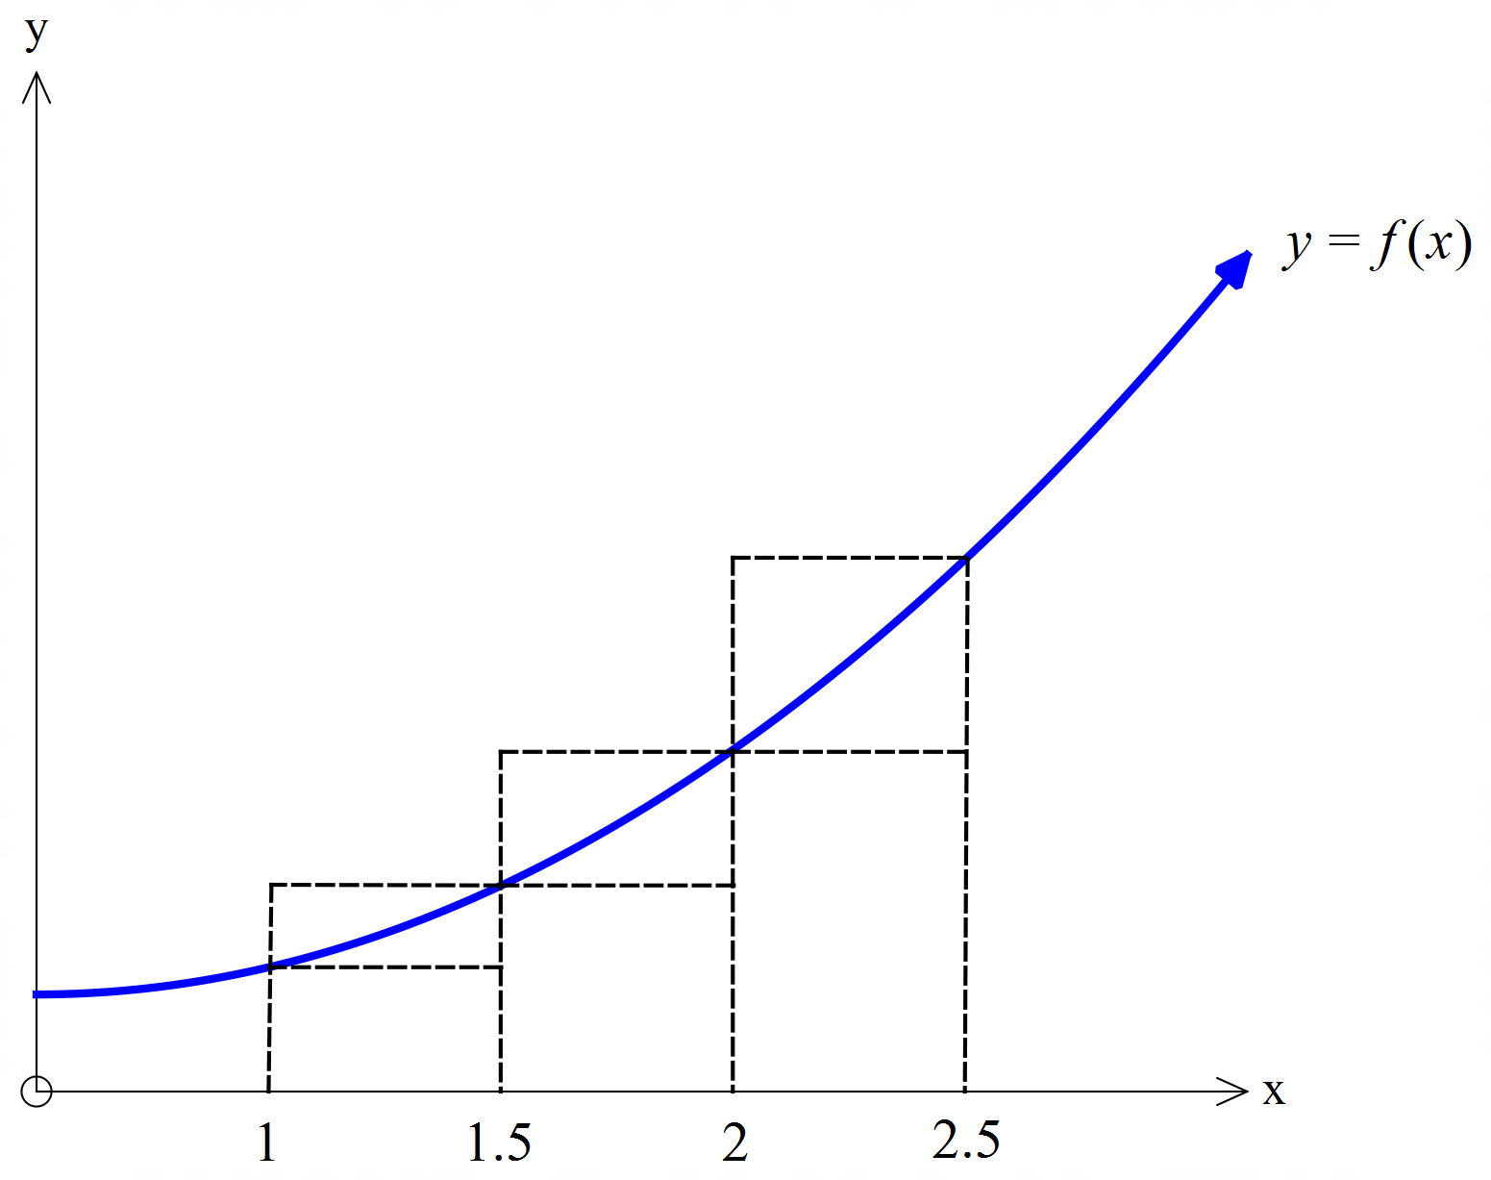

$x$ | 1 | 1.5 | 2 | 2.5
$f(x)$ | 1.8 | 2.6 | 3.8 | 5.4

- By considering the areas of the rectangles shown, demonstrate and explain why
$4.1<\int_{1}^{2.5}{}f\left(x\right)dx<5.9$. (3 marks)

Solution
Upper value=
Lower value=
Definite integral represents area under curve from x=1 to x=2.5 in this context

Specific behaviours
✓ states that integral represents area
✓ shows area of larger rectangles
✓ shows area of smaller rectangles

Consider the table of further values of $f(x)$ given below.

$x$ | 0 | 1 | 1.5 | 2 | 2.5 | 3 | 3.5
$f(x)$ | 1 | 1.8 | 2.6 | 3.8 | 5.4 | 7.3 | 9.6

- Use the table values to determine the best estimate possible for $\int_{1}^{3}{}2f(x)dx$ (4 marks)

Solution
Specific behaviours
✓ shows sum of lower rectangles
✓ shows sum of upper rectangles
✓ uses average
✓ states estimate for 2f(x)

- State two ways in which you could determine a more accurate value for $\int_{1}^{3}{}2f(x)dx$
(2 marks)

Solution
*use smaller widths of rectangles
*model a rule for function and integrate

Specific behaviours
✓ states one reasonable method
✓ states two reasonable methods

Question 14 (8 marks)

A realtor’s sales history over any month can be represented by the following probability distribution:

Number of houses sold in a month | 0 | 1 | 2 | 3 | 4
Probability | 0.15 | 0.4 | 0.3 | 0.1 | 0.05

The realtor is paid $1000 every month with a bonus of $1500 for every house sold up to three houses and a special bonus of $1800 if four or more houses are sold in a month.

Let $X=$ the monthly earning of the realtor.

Determine:

- The expected monthly earning of the realtor, $E(X)$. (4 marks)

Solution
Number of houses sold in a month | 0 | 1 | 2 | 3 | 4
X $ | 1000 | 2500 | 4000 | 5500 | 7300
Probability | 0.15 | 0.4 | 0.3 | 0.1 | 0.05

Specific behaviours
✓ states two values of earnings, X
✓ states all earning values for X
✓ shows calculation for expected value of X
✓ states expected value

- The standard deviation of $X$. (2 marks)

Solution
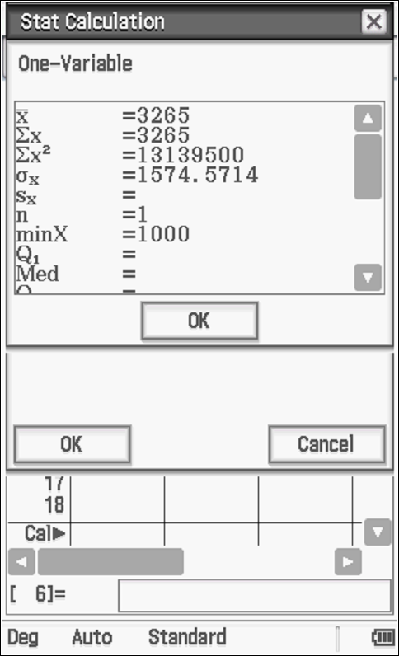
Standard deviation = 1574.57
Specific behaviours
✓ calculates variance
✓ states standard deviation(answer only required for full marks)

- Variance $(5X-3)$. (2 marks)

Solution
Specific behaviours
✓ multiplies by 25 and does NOT subtract 3
✓ states variance(accept standard notation)

Question 15 (8 marks)

Consider a fair die with the numbers . The random variable $X$ is defined as the number of trials of the thrown die showing an even number on top.

- If you throw the die 11 times,

- Determine the probability that you will end up with more even numbers than odd numbers. (2 marks)

Solution
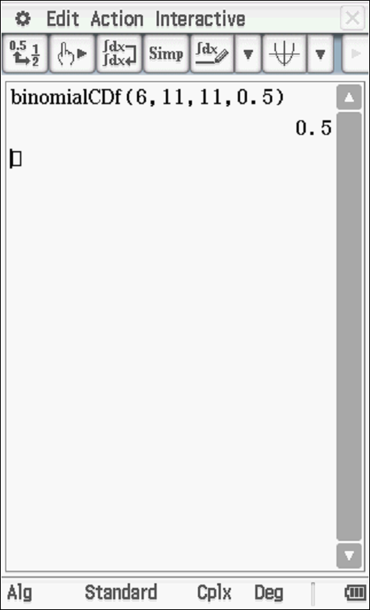

Specific behaviours
✓ uses binomial cdf with correct parameters
✓ states probability

- Determine the probability, to 4 decimal places, that there are in total, even number of times that the die shows an even number. (3 marks)

Solution
Specific behaviours
✓ states binomial dist
✓ states all even values of X
✓ states prob to 4 decimal places

- If you would like to get at least three times an even number. Find the minimum times that you need to throw the die for which the probability of three or more even numbers is at least 85%. (3 marks)

Solution
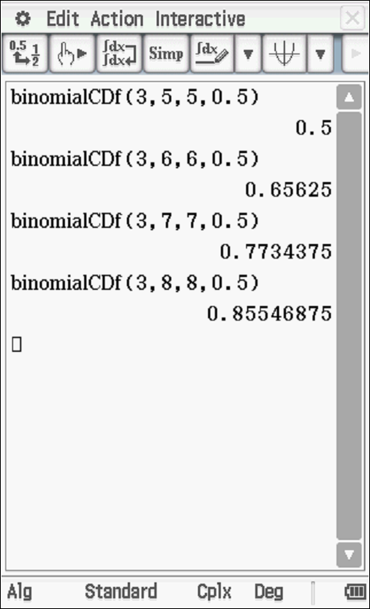

8 throws

Specific behaviours
✓ shows at least two attempts with differing n values
✓ states value of n=7
✓ states n=8

Question 16 (8 marks)

The marginal profit from the sale of $x^{th}$ item is given by $P^{'}\left(x\right)=0.0015x^{2}+1.6x-4.8$, where $P\left(x\right)$ is the profit from selling $x$items.

- Given that the company incurs a loss of $\$70$if no items are sold, find an expression for $P$ in terms of $x$. (3 marks)

Solution
Specific behaviours
✓ integrates
✓ uses a constant
✓ solves for constant

- Hence determine the profit from selling 80 items. (2 marks)

Solution
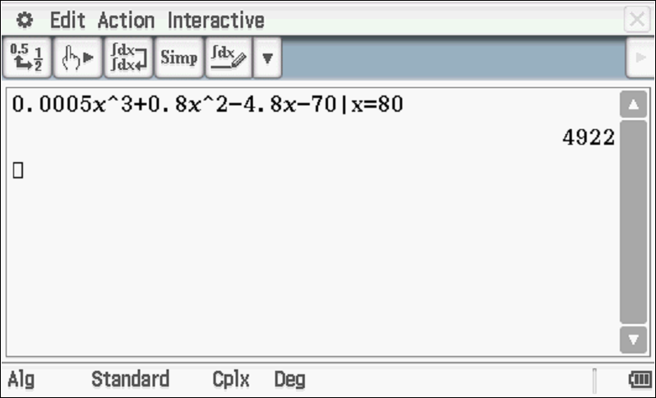
Profit of $4922

Specific behaviours
✓ subs x=80
✓ states profit

- Find the net change in profit if the number of items sold changes from 80 to 160 items.
(3 marks)

Solution
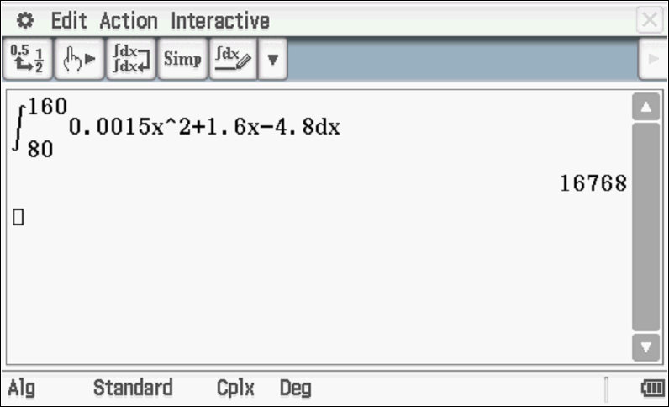

Specific behaviours
✓ uses integration(or antiderivative)
✓ uses correct limits
✓ states net change

Question 17 (10 marks)

The graph of a function $f$is given below.

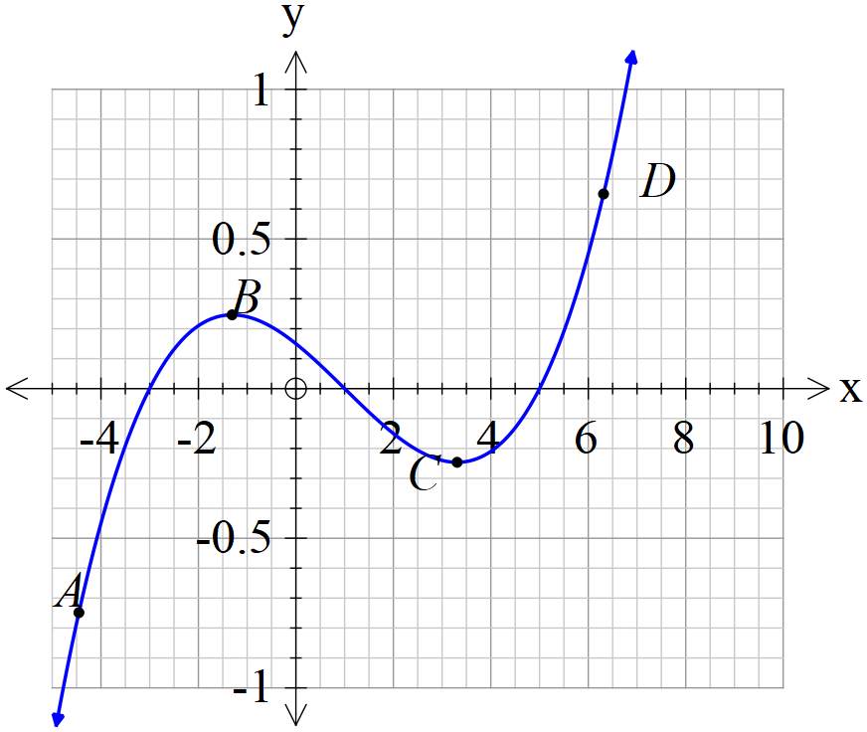

- $A,B,C,D$ are points on the graph of $f$. Determine whether the first and second derivatives are positive, negative or equal to zero at these points. Record your findings in the table below. (4 marks)

Solution
Point | $f'$ | $f''$
A | +ve | -ve
B | zero | -ve
C | Zero | +ve
D | +ve | +ve

Specific behaviours
✓ two correct first derivatives
✓ all first derivatives correct
✓ two correct second derivatives
✓ all second derivatives correct

- Indicate on the graph of $f$ above the inflection point and label as $E$. (1 mark)

Solution
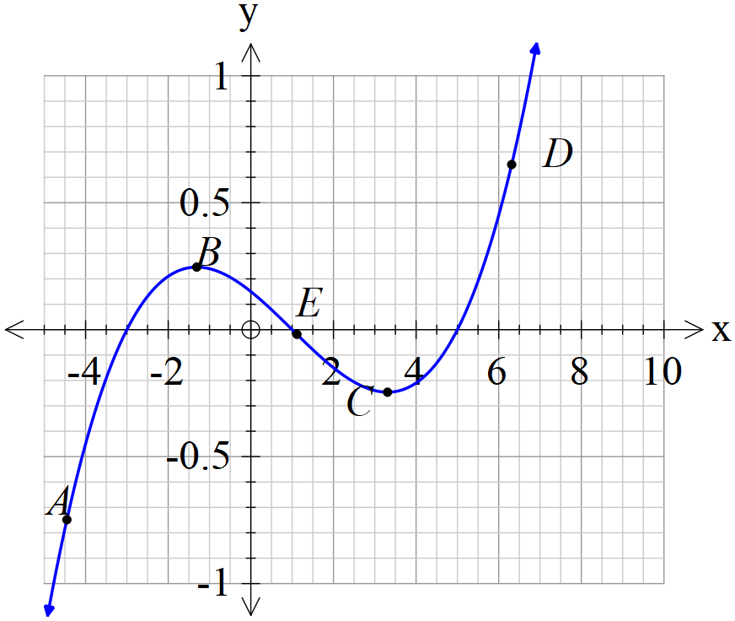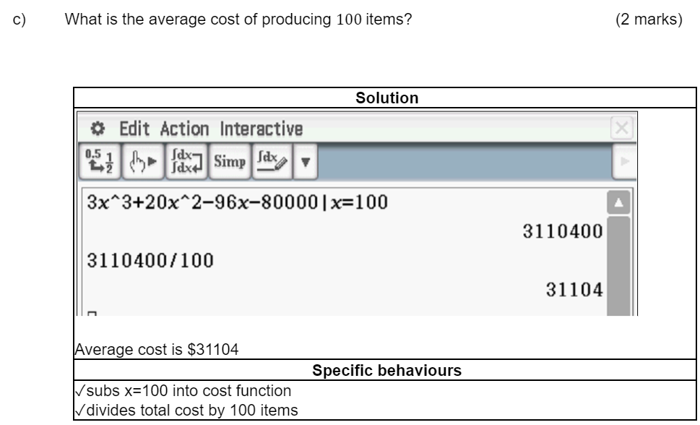

Specific behaviours
✓ shows one approx inflection pt

- Sketch the graph of $f'$ on the same axes as the graph of $f$ above. (5 marks)

Solution
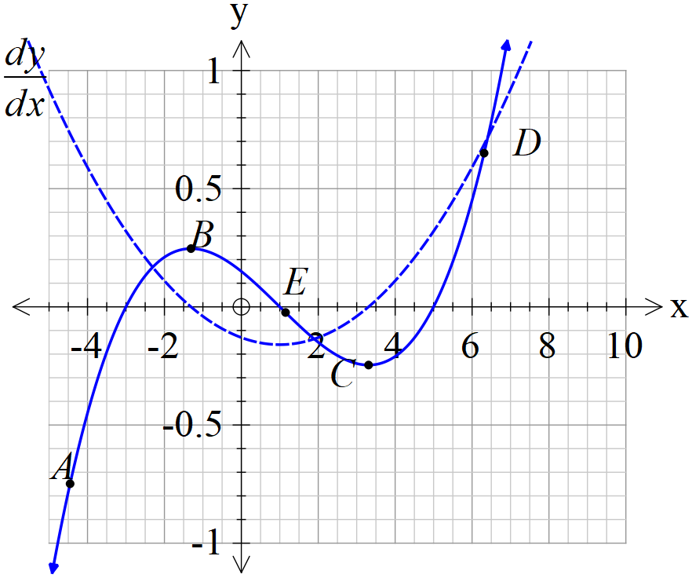

Specific behaviours
✓ concave up for entire domain
✓ x intercept at pt B
✓ x intercept at pt C
✓ y intercept negative
✓ min turning pt at pt E

Question 18 (8 marks)

A hovercraft company has established that for selling units, their revenue function, in dollars, can be given by $R\left(x\right)=3x^{3}+19x^{2}+4x$, and their cost function, in dollars, can be given by $C\left(x\right)=3x^{3}+20x^{2}-96x-80000.$ (Profit=Revenue-cost)

- Using calculus methods, determine the number of units, ,to maximise the profit.
(4 marks)
Solution
Specific behaviours
✓ states profit function
✓ determines derivative and equates to xero
✓ solves for x
✓ uses second derivative sign test(or first) to verify a maximum

- Determine the selling price per unit to establish the maximum profit in (a) above.
(2 marks)

Solution
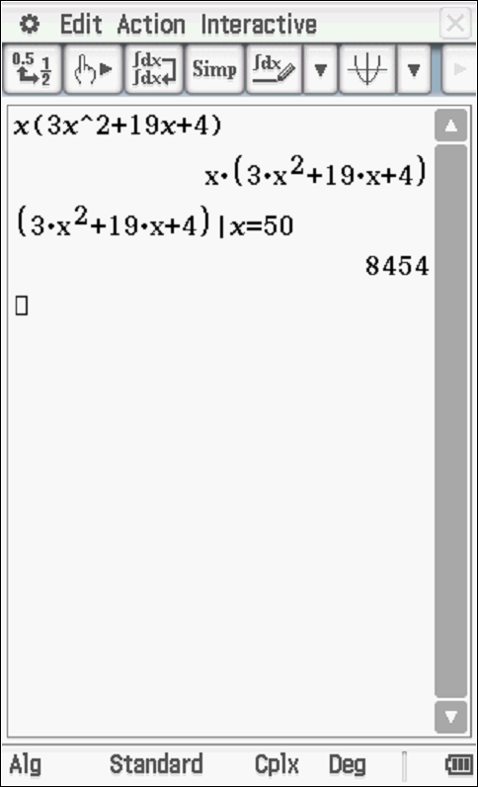
Selling price per unit=$8454

Specific behaviours
✓ factorises revenue
✓ determines selling price for x=50

- What is the average cost of producing $100$items? (2 marks)

Solution
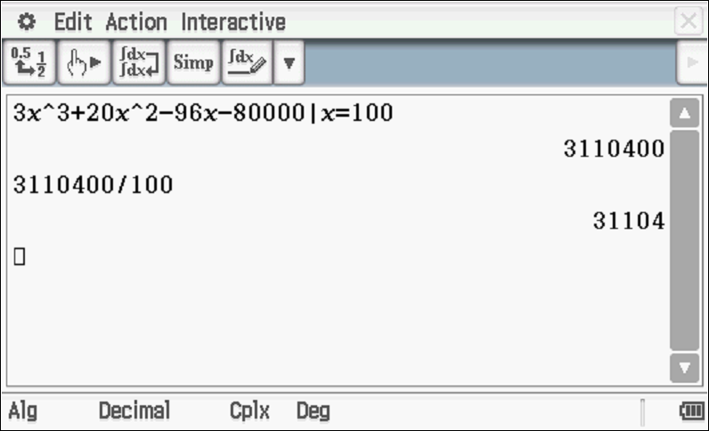

Average cost is $31104
Specific behaviours
✓subs x=100 into cost function
✓divides total cost by 100 items

Question 19 (8 marks)

Consider the following 3 equations, where $m$ is a positive real constant:
$f(x)=x^{2}-3x+4$
$g(x)=3x+4$
$h(x)=mx+4$

The graphs of $y=f(x)$ and $y=g(x)$ are shown on the axes below.

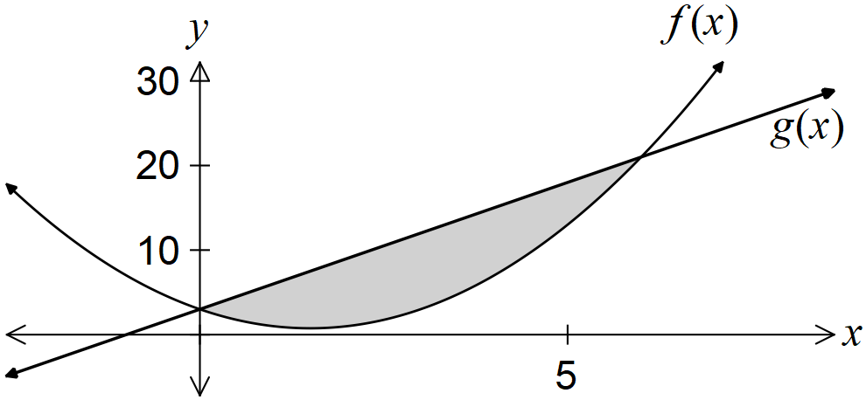

- State the integral required to calculate the shaded area. (2 marks)

Solution
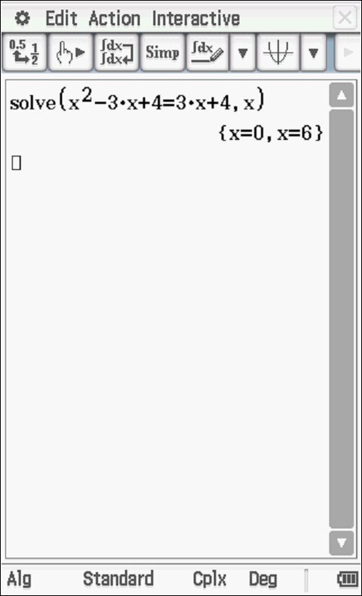

Specific behaviours
✓ states limits
✓ shows integral of difference for positive area

- Show that the graphs of $y=f(x)$ and $y=h(x)$ intersect when $x=0$ and $x=m+3$.
(2 marks)
Solution
Specific behaviours
✓ equates functions and factorises
✓ states both x values

- The area trapped between the graphs of $y=f(x)$ and $y=h(x)$ is 36 square units. Determine the value of $m$. (4 marks)

Solution
Specific behaviours
✓ shows integral in terms of m
✓ sets up equation with integral for m
✓ shows integration equation for m
✓ solves for m

Question 20 (8 marks)

On a tarmac of a wide airfield is a rotating light that has two complete revolutions per second.
( radians/second) The light is placed 200 metres in front of a long brick wall as shown in the diagram below. As the light is shone against the wall, the spot of light can be seen racing across the wall. Let = the displacement of the spot of light from the point closest to the light, point O, on the wall.

c) Determine the velocity of the spot of light, in metres/second, when radians.
(Hint- use with ) (3 marks)

Solution
Specific behaviours
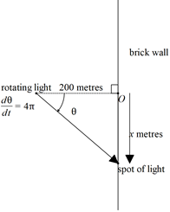
✓ differentiates x wrt
✓ uses chain rule with correct angle
✓ obtains approx value of velocity

d) Determine the acceleration of the spot of light when radians. (4 marks)

Solution
Specific behaviours
✓ differentiates velocity wrt time
✓ uses chain rule
✓ subs required angle and rate
✓ obtains an approx value for acceleration(no need of units) or exact un-simplified

Additional working space
Question number: _______

Additional working space
Question number: ________

Additional working space
Question number: ________

